Mixed-Shape Composition

Definition
# Source: AI Source: Provided by: [Data Path: Persons Table -> ID Column: 1, Name_En Column: Motasem Essam] -> From: [ChatGPT] on [7/25/2026]
Mixed-Shape Composition is a type of geometric figure composition in which two or more different types of geometric shapes are combined to form a single composite figure.
The shapes may be joined along edges, attached along curved boundaries, placed next to one another, or combined in other ways. The resulting figure can contain both straight and curved boundaries.
Simple definition: Mixed-shape composition is combining different kinds of geometric shapes to create one larger figure.
Examples include:
- A rectangle joined to a semicircle.
- A triangle placed on top of a rectangle.
- A square containing a circular region.
- A rectangle combined with a quarter-circle and a triangle.

Main Classification
# Source: AI Source: Provided by: [Data Path: Persons Table -> ID Column: 1, Name_En Column: Motasem Essam] -> From: [ChatGPT] on [7/25/2026]
The following is a practical classification, not a universally standardized mathematical taxonomy. These categories describe common ways of combining different shapes and may overlap.

1. Polygon–Circle Composition
# Source: AI Source: Provided by: [Data Path: Persons Table -> ID Column: 1, Name_En Column: Motasem Essam] -> From: [ChatGPT] on [7/25/2026]
Combines a polygon with a circle or part of a circle.
Example: A rectangle with a semicircle attached to one side.
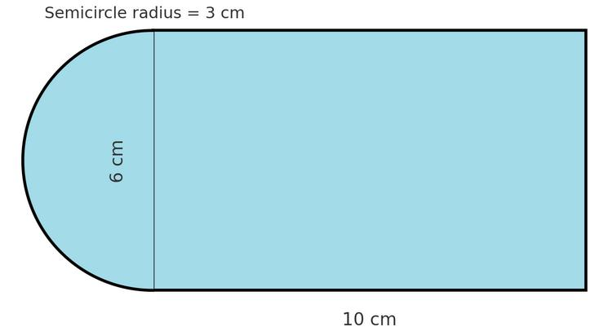
Detailed Explanation and Examples
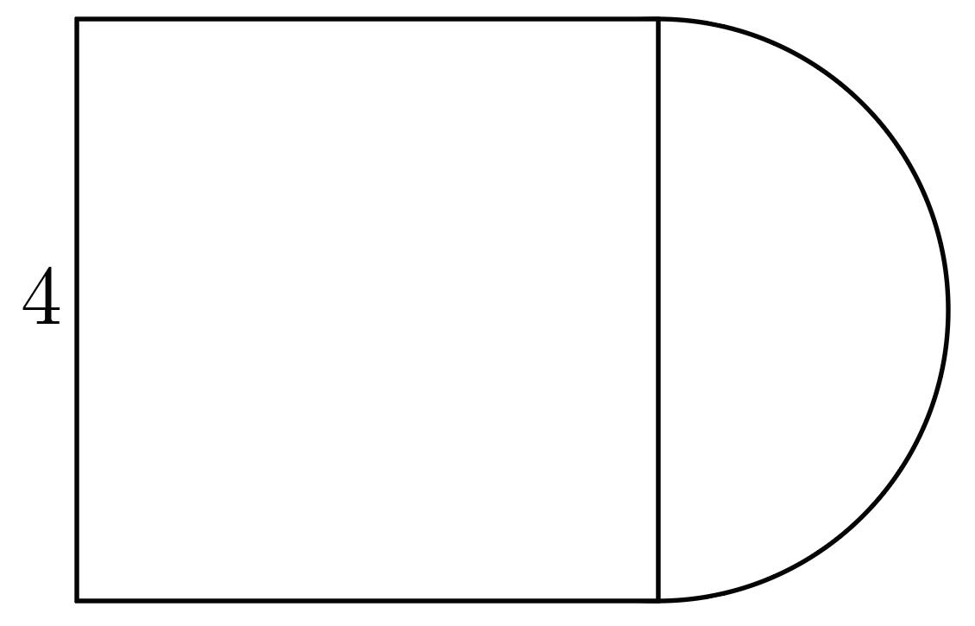
Definition: A composition formed by combining a polygon, such as a triangle, square, or rectangle, with a circle or a circular part.
Example: A rectangle of length $L=8$units and width $2r=6$units is joined to a semicircle of radius $r=3$units along one short side.
The total area is the sum of the rectangle's area and the semicircle's area:
$$A_{\text{total}}=A_{\text{rectangle}}+A_{\text{semicircle}}$$
$$A_{\text{total}}=L\left(2r\right)+\frac{1}{2}πr^{2}$$
Substituting the values:
$$A_{\text{total}}=8\left(6\right)+\frac{1}{2}π{\left(3\right)}^{2}$$
$$\boxed{A_{\text{total}}=48+\frac{9π}{2}}$$
The approximate area is $62.14$square units.

2. Polygon–Polygon Composition
# Source: AI Source: Provided by: [Data Path: Persons Table -> ID Column: 1, Name_En Column: Motasem Essam] -> From: [ChatGPT] on [7/25/2026]
Combines two or more different polygons.
Example: A triangle joined to a rectangle to form a house-like outline.
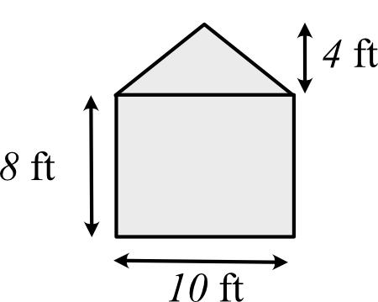
Detailed Explanation and Examples
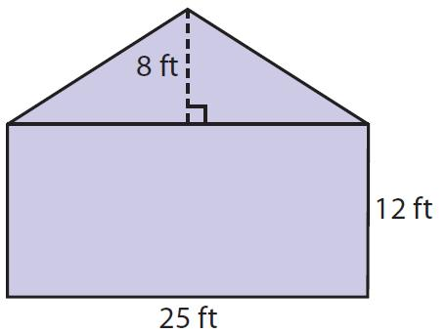
Definition: A composition formed by joining two or more polygons, potentially with different numbers of sides.
Example: A rectangle with width $8$units and height $4$units has a triangle attached above it. The triangle has base $8$units and height $3$units.
Rectangle area:
$$A_{1}=8×4=32$$
Triangle area:
$$A_{2}=\frac{1}{2}\left(8\right)\left(3\right)=12$$
Total area:
$$\boxed{A_{\text{total}}=32+12=44}$$
This addition works because the two regions have non-overlapping interiors.

3. Polygon–Circular-Sector Composition
# Source: AI Source: Provided by: [Data Path: Persons Table -> ID Column: 1, Name_En Column: Motasem Essam] -> From: [ChatGPT] on [7/25/2026]
Combines a polygon with a circular sector or another part of a circle.
Example: A rectangle joined to a quarter-circle.
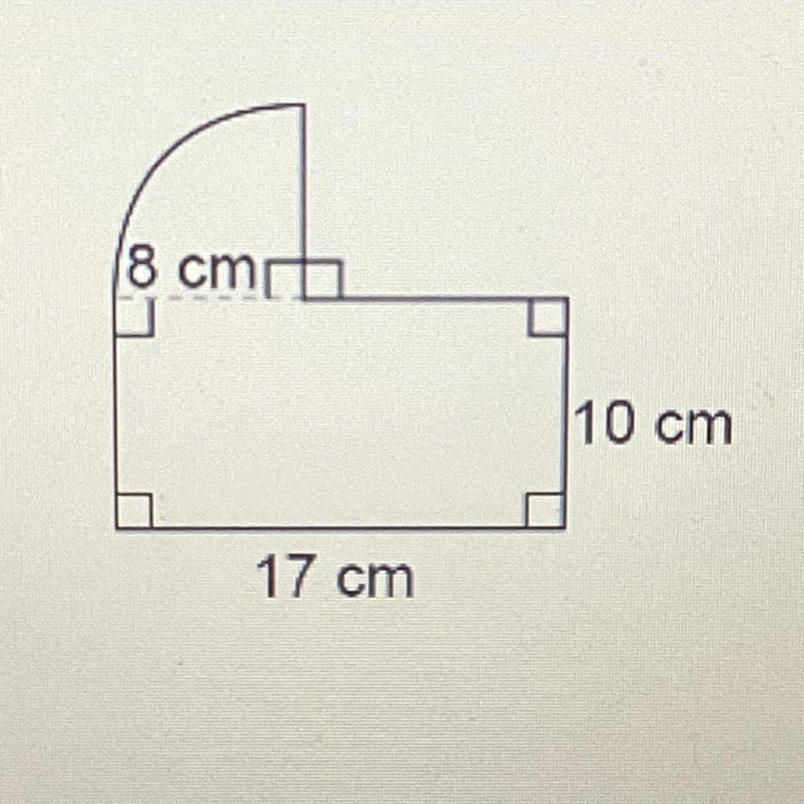
Detailed Explanation and Examples
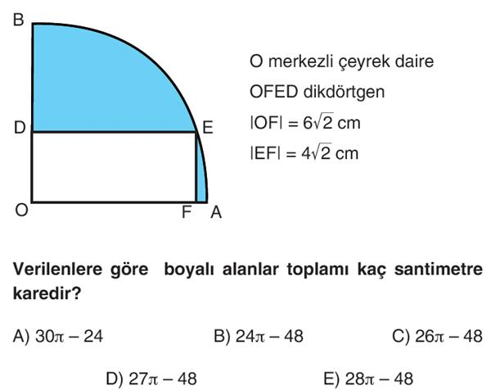
Definition: A composition in which a polygon is combined with a circular sector, quarter-circle, or another portion of a circular region.
Example: A rectangle measuring $8×4$units is combined with a quarter-circle of radius $4$units, with no overlapping interiors.
Rectangle area:
$$A_{1}=8×4=32$$
Quarter-circle area:
$$A_{2}=\frac{1}{4}π{\left(4\right)}^{2}=4π$$
Total area:
$$\boxed{A_{\text{total}}=32+4π}$$
The area is approximately $44.57$square units.

4. Nested Mixed-Shape Composition
# Source: AI Source: Provided by: [Data Path: Persons Table -> ID Column: 1, Name_En Column: Motasem Essam] -> From: [ChatGPT] on [7/25/2026]
Places different types of shapes inside one another.
Example: A square containing a circle, with a triangle inside the circle.
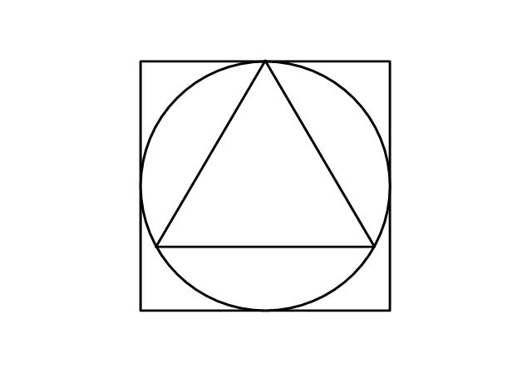
Detailed Explanation and Examples
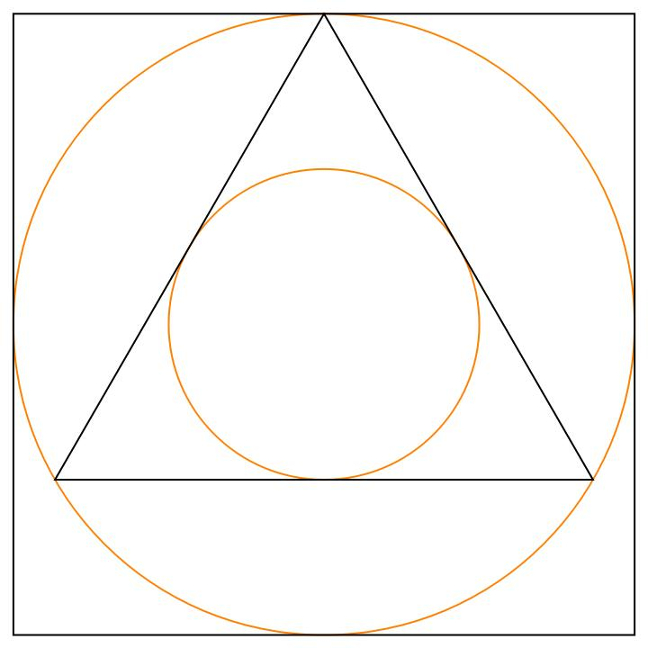
Definition: A composition in which one type of geometric shape is contained within another, with at least two different shape types involved.
Example: A square of side $10$units contains a circle of radius $4$units. The circle contains a triangle whose area is $12$square units.
Square area:
$$A_{\text{square}}={10}^{2}=100$$
Circle area:
$$A_{\text{circle}}=π{\left(4\right)}^{2}=16π$$
The area inside the square but outside the circle is:
$$\boxed{100-16π}$$
The triangle's area is not added to the square's area because it is already contained within the circle and square. For the same reason, nested regions must be handled carefully to avoid double-counting.

5. Multiple Mixed-Shape Composition
# Source: AI Source: Provided by: [Data Path: Persons Table -> ID Column: 1, Name_En Column: Motasem Essam] -> From: [ChatGPT] on [7/25/2026]
Combines three or more different shape types in one configuration.
Example: A rectangle, a triangle, and a semicircle combined into one figure.
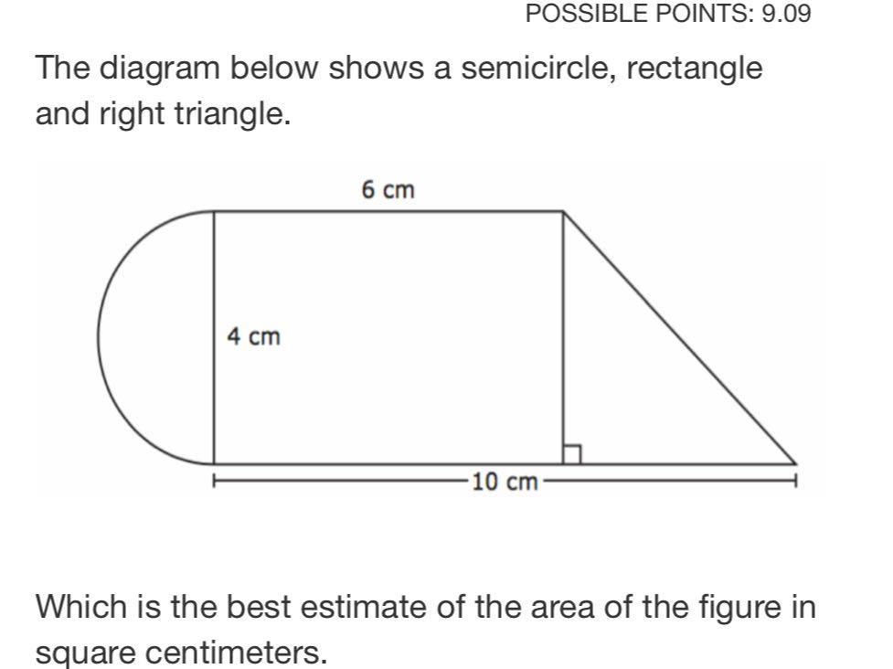
Detailed Explanation and Examples
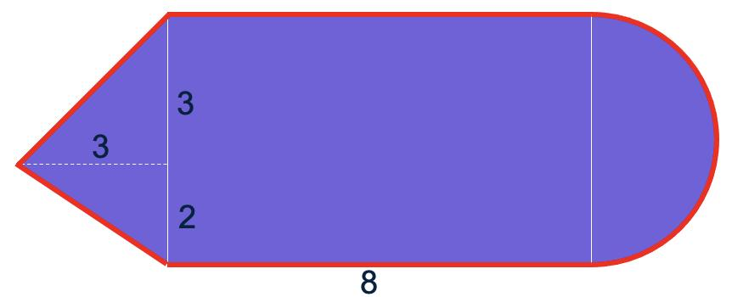
Definition: A composition involving three or more different shape types within a single figure.
Example: A composite figure consists of:
- A rectangle measuring $10×4$units.
- A triangle attached to the rectangle, with base $4$and height $3$.
- A semicircle attached along a side of length $4$, giving it radius $2$.
Their individual areas are:
$$A_{1}=10\left(4\right)=40$$
$$A_{2}=\frac{1}{2}\left(4\right)\left(3\right)=6$$
$$A_{3}=\frac{1}{2}π{\left(2\right)}^{2}=2π$$
Assuming the regions have non-overlapping interiors:
$$\boxed{A_{\text{total}}=46+2π}$$
The approximate area is $52.28$square units.

6. Overlapping Mixed-Shape Composition
# Source: AI Source: Provided by: [Data Path: Persons Table -> ID Column: 1, Name_En Column: Motasem Essam] -> From: [ChatGPT] on [7/25/2026]
Combines different shape types whose regions overlap.
Example: A circle overlapping a rectangle.
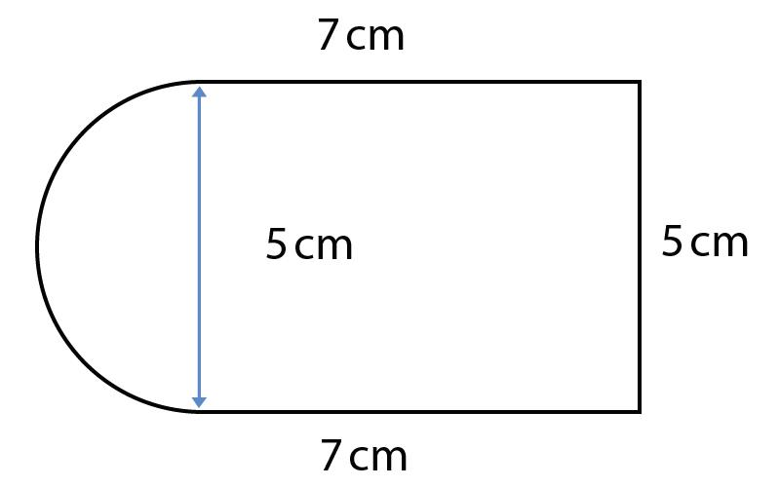
Detailed Explanation and Examples
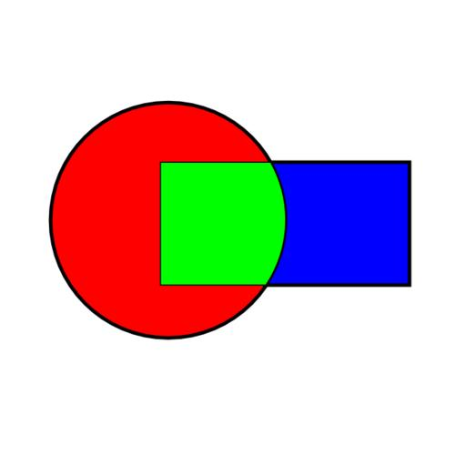
Definition: A composition in which different types of shapes occupy some of the same region.
Example: A rectangle of area $30$square units overlaps a circle of area $25π$square units. Suppose their intersection has area $6$square units.
To find the area covered by either shape, subtract the overlap once:
$$A_{\text{union}}=A_{1}+A_{2}-A_{\text{intersection}}$$
$$\boxed{A_{\text{union}}=30+25π-6=24+25π}$$
The key principle is that an overlapping region must not be counted twice.

Important Formulas
# Source: AI Source: Provided by: [Data Path: Persons Table -> ID Column: 1, Name_En Column: Motasem Essam] -> From: [ChatGPT] on [7/25/2026]
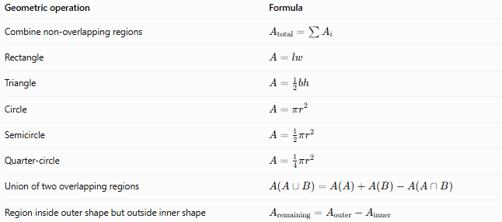
Geometric operation | Formula
Combine non-overlapping regions | $$A_{\text{total}}=\sum{A_{i}}$$
Rectangle | $$A=lw$$
Triangle | $$A=\frac{1}{2}bh$$
Circle | $$A=πr^{2}$$
Semicircle | $$A=\frac{1}{2}πr^{2}$$
Quarter-circle | $$A=\frac{1}{4}πr^{2}$$
Union of two overlapping regions | $$A\left(A∪B\right)=A\left(A\right)+A\left(B\right)-A\left(A∩B\right)$$
Region inside outer shape but outside inner shape | $$A_{\text{remaining}}=A_{\text{outer}}-A_{\text{inner}}$$
Perimeter caution: When finding the outer perimeter of a composite figure, do not count shared internal edges. Only the boundary exposed on the outside contributes to the composite figure's perimeter.

Mixed-Shape Composition vs. Other Types
# Source: AI Source: Provided by: [Data Path: Persons Table -> ID Column: 1, Name_En Column: Motasem Essam] -> From: [ChatGPT] on [7/25/2026]
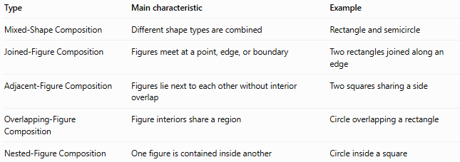
Type | Main characteristic | Example
Mixed-Shape Composition | Different shape types are combined | Rectangle and semicircle
Joined-Figure Composition | Figures meet at a point, edge, or boundary | Two rectangles joined along an edge
Adjacent-Figure Composition | Figures lie next to each other without interior overlap | Two squares sharing a side
Overlapping-Figure Composition | Figure interiors share a region | Circle overlapping a rectangle
Nested-Figure Composition | One figure is contained inside another | Circle inside a square
These classifications are not mutually exclusive. For example, a rectangle and semicircle joined along a side form both a mixed-shape composition and a joined-figure composition.

Classification Summary
# Source: AI Source: Provided by: [Data Path: Persons Table -> ID Column: 1, Name_En Column: Motasem Essam] -> From: [ChatGPT] on [7/25/2026]
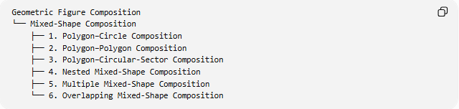
Geometric Figure Composition
└── Mixed-Shape Composition
├── 1. Polygon–Circle Composition
├── 2. Polygon–Polygon Composition
├── 3. Polygon–Circular-Sector Composition
├── 4. Nested Mixed-Shape Composition
├── 5. Multiple Mixed-Shape Composition
└── 6. Overlapping Mixed-Shape Composition

Key Points
# Source: AI Source: Provided by: [Data Path: Persons Table -> ID Column: 1, Name_En Column: Motasem Essam] -> From: [ChatGPT] on [7/25/2026]
- Mixed-shape composition combines different geometric shape types.
- The shapes may be polygons, circles, circular sectors, or other geometric figures.
- Area is additive when the component regions have non-overlapping interiors.
- Overlapping regions require subtraction of the intersection to avoid double-counting.
- Nested shapes require distinguishing between the area of a whole figure and the areas of its contained regions.
- The classification above is practical and descriptive; categories can overlap.

Conclusion
# Source: AI Source: Provided by: [Data Path: Persons Table -> ID Column: 1, Name_En Column: Motasem Essam] -> From: [ChatGPT] on [7/25/2026]
Mixed-Shape Composition is a useful category of geometric figure composition for describing figures formed from different kinds of shapes. It is particularly useful in geometry problems involving composite areas, perimeters, diagrams, and spatial configurations. The essential step in solving these problems is to identify each component shape, understand how the components relate to one another, and apply the appropriate geometric formulas without double-counting shared or overlapping regions.

